**Cube Hedgehog**

Cube Hedgehogs appear in the base game in their corrupted form just like Cube Bunny.

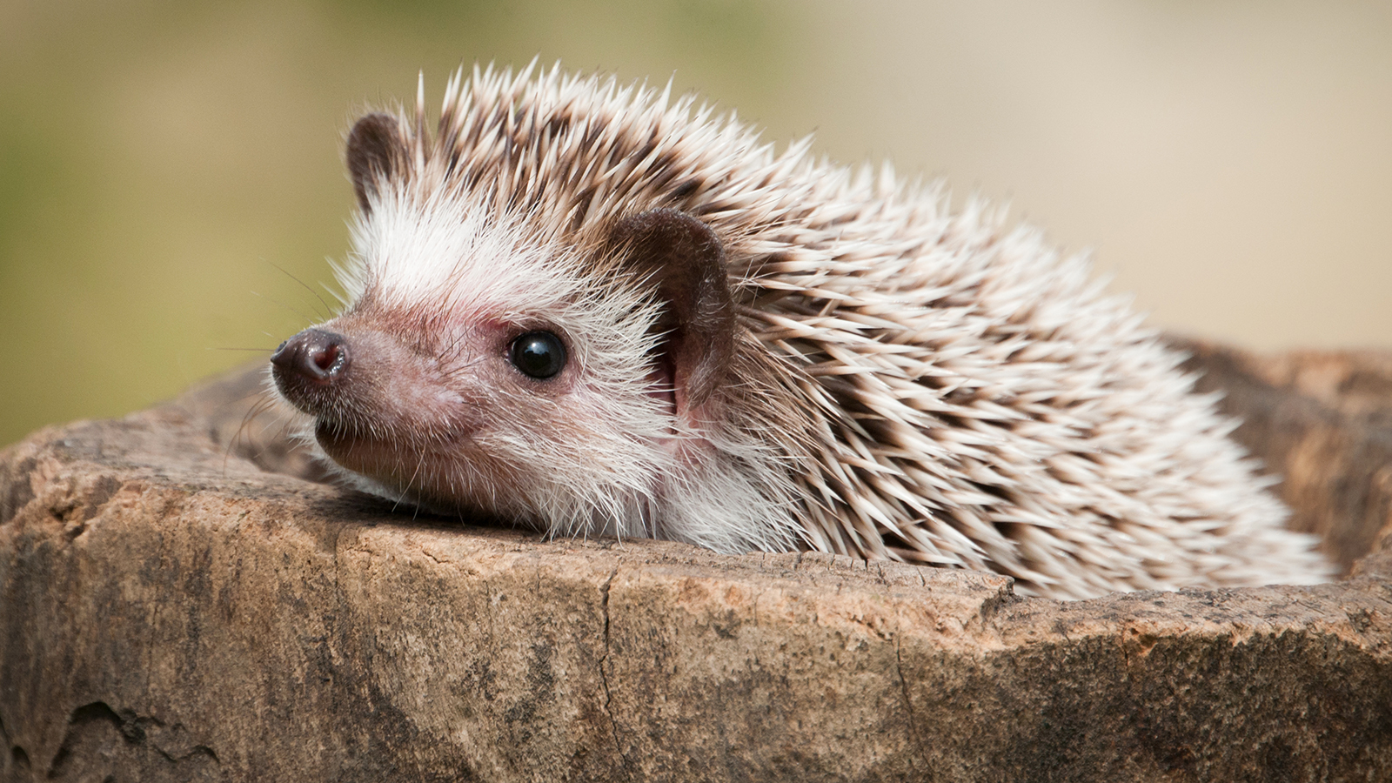

As all other cube characters it has a cubic / square base body.

On its head and at the opposite side of which it is facing towards it has its quills.

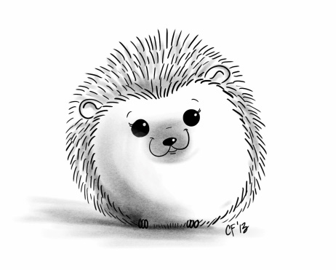The quills appear short and point lightly upwards and into the opposite direction of which it is facing at.

Its face appears like a comic-version of a hedgehog’s face like on the pictures.

Its eyes are red and between the face and the quill may be a hint of an ear.

The quills have black pointy tips while the rest of the cube hedgehog is held in natural colors as above.  
The eyes are red just like those of the cube bunny.

Abilities:

When a player approaches it (horizontally), it will cover up and extend its quills.  
The quills point in all directions above the surface it is standing on.  
The face will squeeze its eyes shut and be lowered as a whole, while the quills take most of the visual appearance.

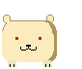

*Here a first draft without the quills.*